https://leetcode.com/problems/total-distance-traveled/submissions/2191289101/

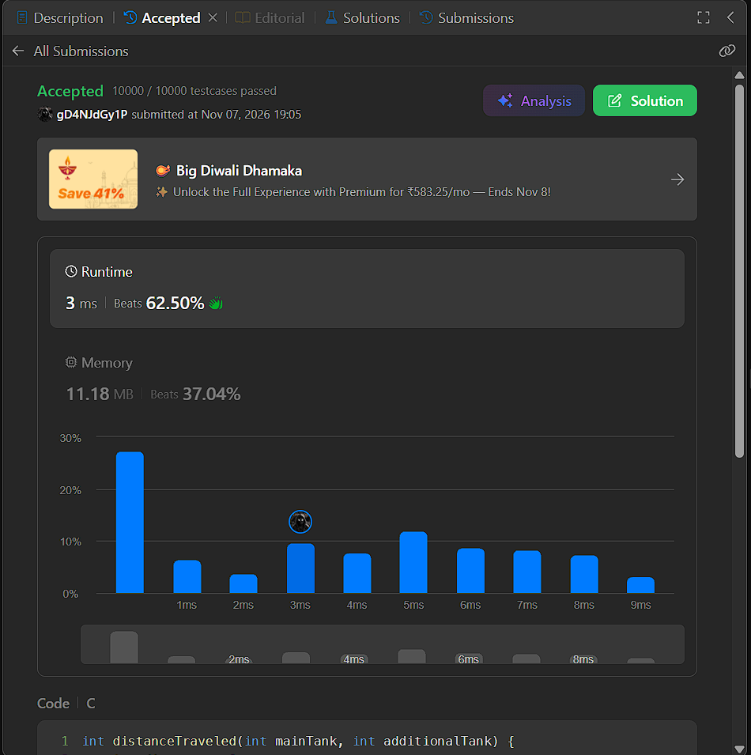

CODE :
int distanceTraveled(int mainTank, int additionalTank) {
int distance = 0;
while (mainTank >= 5) {
mainTank -= 5;
distance += 50;
if (additionalTank > 0) {
mainTank++;
additionalTank--;
}
}
distance += mainTank * 10;
return distance;
}

